* Tampilan TextFieldDemo.java

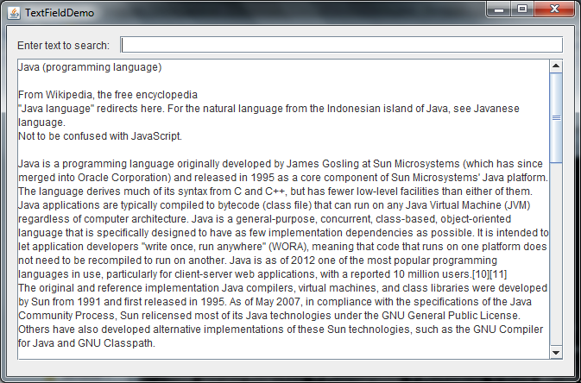

* Tampilan ButtonDemo.java

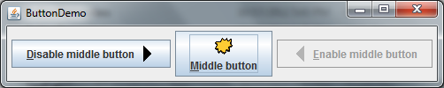

* Tampilan CheckBoxDemo.java

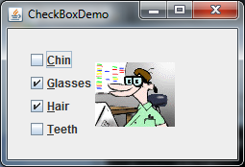

* Tampilan RadioButtonDemo.java

